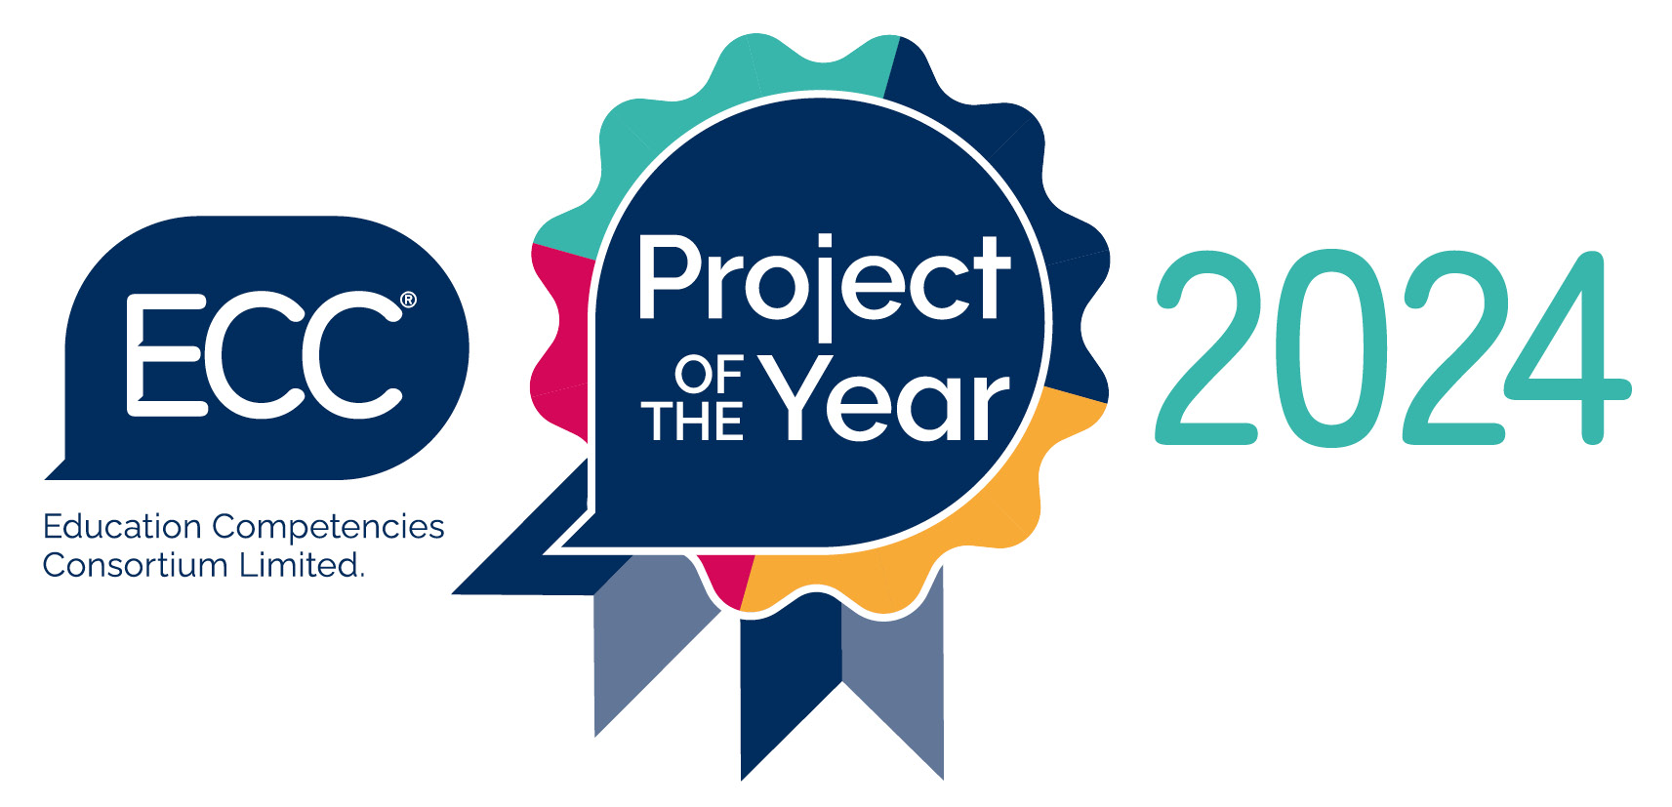Award Application

Project title

Organisation name

Contact Name

Job Title

Email Address

Telephone Number

QUESTION 1
What were the project aims? (eg. what did you set out to achieve, what problem were you trying to solve, what improvements were you trying to make?)
(maximum of 350 words for this box)
Word count:

QUESTION 2
What did you do? (ie. describe the process, actions taken)
(maximum of 350 words for this box)
Word count:

QUESTION 3
What was the impact of the project, and what were the benefits? (eg. difference made, learning, objectives achieved). Your project should have been completed, or near completion, by the end of September 2024.
(maximum of 350 words for this box)
Word count:

Thank you for completing your application.

Please send your completed form to contactus@ecc.ac.uk no later than 5pm on Friday 18 October 2024.

By returning this Award Application you consent to ECC storing the information in it electronically and sharing this with members of the judging panel in order to process nominations and make award decisions. Entrants may be featured in publicity, including newsletters, website content and the 2024 ECC Annual Conference. The Award-winning organisation will be expected to contribute to the development of a case study for use by ECC featuring the winning project.

